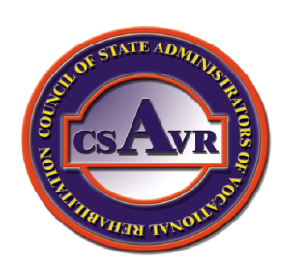
Council of State Administrators of Vocational Rehabilitation
1 Research Court, Suite 450
Rockville, MD 20850
(301) 519-8023 phone
www.rehabnetwork.org

CHIEF EXECUTIVE OFFICER
July 27, 2013

The Honorable Tom Harkin, Chairman
Health, Education, Labor and Pensions Committee

The Honorable Lamar Alexander, Ranking Member
Health Education, Labor and Pensions Committee

Re: Recommendations for Changes in Legislative Language in the Manager’s Package of Amendments for S. 1356.

Dear Chairman Harkin and Ranking Member Alexander:

The Council of State Administrators of Vocational Rehabilitation (CSAVR),as requested by HELP Committee staff, is submitting recommendations for changes in legislative language to S. 1356. The attached document outlines CSAVR’s recommendations and the rationale for the proposed recommendations. CSAVR also wishes to remain on record as opposing S. 1356. We strongly believe the move of the Rehabilitation Services Administration (RSA) from the U.S Department of Education to the U. S. Department of Labor (DOL) threatens the integrity of individualized services to persons with the most significant disabilities and there is no compelling evidence to support that the move and its costs will result in better services for individuals with disabilities. In fact, all the evidence that we are aware of, especially in light of the continuing focus on transition youth services and outcomes, points to the contrary.

We believe that over time the DOL traditional model of rapid placement will disenfranchise vocational rehabilitation consumers. The generic DOL system is not designed to accommodate for the holistic and unique needs of individuals with disabilities who require a comprehensive career plan to gain, maintain or return to employment and be independent. This is why the Rehabilitation Act was not made a part of Title I of WIA originally, and the basis for that decision still holds and has continued to be supported by research and studies.

The CSAVR believes the proposed move to DOL also conflicts with the increasing demand to serve more youth in transition. The linkages and collaborative relationships that currently exist between Vocational Rehabilitation, Special Education and the public school system will ultimately be eroded if the RSA is relocated. S. 1356 places greater responsibility on VR to serve students; moving RSA from the Department of Education seems to contradict logic. Further, it creates additional obstacles because of the added requirement to cooperate across department lines.

We also wish to express our disappointment in the process that has been used to develop S. 1356. This professional organization, consumers, business and other stakeholders have been marginalized by not having ample opportunity digest the significant changes to Title V. Regardless of the reason for the unrealistic timeframe to review and respond, it shows a lack of respect for public engagement and input. Our consumers deserve to be heard and for the larger disability community to be engaged in dialogue. As it is, legislation has been drafted in isolation without adequate consumer and constituent participation.

Stephen A. Wooderson
swooderson@rehabnetwork.org
OFFICERS
President
Kim Peck
Minneapolis, MN
President-Elect
Betsy Hopkins
Augusta, ME
Secretary/Treasurer
Russell Cusack
Bismarck, ND

REGIONAL REPS
Region I
Diane Dalmasse
Waterbury, VT
Region II
Region III
Robert Doyle
New Castle, DE
Region IV
Butch McMillan
Jackson, MS
Region V
Richard Strong
St. Paul, MN
Region VI
Mark Martin
Baton Rouge, LA
Region VII
Mark Schultz
Lincoln, NE
Region VIII
Jim Marks
Helena, MT
Region IX
Region X
Don Alveshere
Boise, ID
COMMITTEE CHAIRS
Direct Client Services
Sue Page, MD Combined
Deaf, Hard of Hearing,
Late Deafened & Deaf Blind
Alice Hunnicutt, NJ General
Richard Strong, MN Blind
Employment
Ralph Vigil, NM General
Human Resource Development
Anthony Sauer, CA Combined
Legislative
Jim Hanophy, TX General
Management Services
Lisa Hatz, NH Combined
Butch McMillan, MS Combined
Rehabilitation Research
Mark Schultz, NE General
Social Security Relationships
Don Uchida, UT Combined
Transition
Andrea Guest, DE General
Veterans
David Mitchell, IA General

As filed, the CSAVR will continue to strongly oppose S. 1356 as long as the move from RSA to DOL remains in language because there is no evidence that such a move will improve services. Our submission of suggested language to further protect the integrity of the VR program’s staff and resources should not be construed as implicit acceptance of the bill; nor it is to be considered as the CSAVR “fall back” position should the bill proceed to the floor.

Please find attached our recommendations and rationale for changes to S. 1356.

Respectfully submitted,
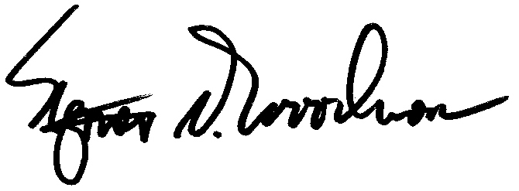
Stephen A. Wooderson
Chief Executive Officer
CSAVR

