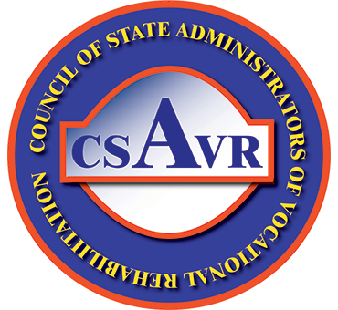
Vision 2020 Four Principles

VR is driven by a commitment to people with disabilities and businesses at the intersection of ability and the demand for talent.

Principle #1: Innovating Solutions to achieve greater access to and use of vocational rehabilitation services. Our goal is to achieve the most effective outcomes for our customers.

Principle #2: Building careers and retaining talent in America’s workforce by investing expertise and resources to benefit our customers.

Principle #3: Customizing Services and Expertise that provide flexible supports and services. We accomplish this through specialized strategies to meet the workforce goals of our customers.

Principle #4: Leading and Engaging in Collaborative Strategies with our partners who are working with us to achieve greater collective impact at all system levels (national, state, and local).

