
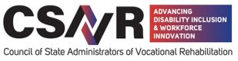
​

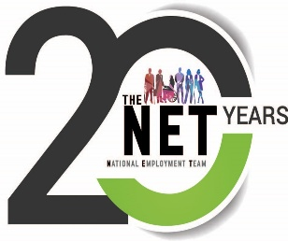
2025 NET Summit Agenda

September 3-4, 2025

The Microsoft Campus
Conference Center – McKinley
1 Microsoft Way, Redmond, WA 98052

Marriott Hotel
7401 164th Ave NE ● Redmond, WA 98052
(425) 498-4000
​
Wednesday, Sept. 3rd Microsoft Campus
9:00 – 11:45 Welcome and Introductions: Microsoft and CSAVR-NET

  - Microsoft - HR Welcome
  - Accessibility at Microsoft
  - Microsoft Neurodiversity Program – Panel on Hiring
  - Skilling and Upskilling for Roles at Microsoft
  - AI/Copilot/disability inclusion at Microsoft

11:45 a.m. – 1:00 p.m. LUNCH Networking Roundtables
1:00 p.m. – 3:30 p.m. Businesses presenting on topics related to our NET Partnership. Day 1 or Day 2.
- Amazon
- Cleanlogic
- Convergint
- McLane Company
- Walmart

3:30 pm – 4:00 pm, Questions and follow-up from businesses
Thursday, Sept. 4th Microsoft Campus

9:00 – 11:45 Welcome and Introductions: Various Businesses presenting on topics related to the NET Partnership. Day 1 or Day 2.
- Amazon
- Cleanlogic
- Convergint
- McLane Company
- Walmart

11:45 a.m. – 1:00 p.m. LUNCH NETworking Roundtables
1:00 p.m. – 3:00 p.m.
National Updates
- TAC-QE Updates – Tim Tansey and Harley Engelman
- NET Working Series – Kathy and Harley
- TAP and the ACT Virtual Academy – Mike Corso

Topics: Group Discussion
- Business Relations Teams –Structures and Reporting Strategies at the State Level: Jenny Piatt, MI; WA-DSB and DVR partnership
- Apprenticeships and Work-based Learning Strategies
    - DBVI Career Cindy Roberts, Director of Business and Corporate Initiative VA- DBVI and
    - Tyler Boone, our new CVS Health Career Skills Lab Instructor, VA-DBVI
- Careers in the Gig Economy

2:30 – 3:30 NET Feeback and Closing Remarks

